Custom Orthotics Order Form
PLEASE NOTE: CUSTOM INSERTS ARE NON-REFUNDABLE.
This Form Must Be Sent to Orthofeet with the Corresponding Impression Foam Box: ATTENTION: CUSTOMS DEPARTMENT

ACCOUNT NO: _______________PURCHASE ORDER NO: ___________________________

CONTACT: ________________PHONE: ______________FAX: ____________EMAIL: _____________

SHIP TO:

ADDRESS:

CITY/STATE/ZIP:

PATIENT NAME: _______________________________GENDER (PLEASE CIRCLE) MALE/FEMALE
SHOE STYLE: ________________________COLOR: ____________SIZE:________WIDTH: ________

FUNCTIONAL CUSTOM ORTHOTICS (L3020)

PLEASE INDICATE # OF PAIRS: 1 2 3
BASE MATERIALS (L3020 only): Please Check All That Apply:  ________Co-Poly Length:  ________EVA  ________Puff Full_________  ________Polypropylene  ________Pelite Sulcus______  ________Cork  ________UCBL* Met ¾ _______  ________Carbon Plating*  *(Additional Charges Will Apply)* | ORTHOTIC COVERS:  ______P-Cell  ______Tri-Lam  ______Vinyl  ______Leather  ______Spenco  __EVA (multicolored) _____1/8” ______ 1/16”  __EVA (solid colored)_____1/8” ______ 1/16”  ______Plastazote ______ 1/8” ________3/16”  HEEL POSTINGS please circle: YES NO  OTHER:_________________________

CUSTOM DIABETIC ORTHOTICS
Custom Orthotics  (A5514)  PLEASE CIRCLE # OF PAIRS  1 2 3  BY DEFAULT 3 PAIRS WILL BE FABRICATED PER MEDICARE GUIDELINES | Single Custom Orthotics  (A5514)  PLEASE INDICATE QUANTITY BELOW  RIGHT: 1 2 3  LEFT: 1 2 3 | Orthotic with Toe Filler  (L5000)  PLEASE INDICATE # OF FILLERS  RIGHT: 1 2 3  LEFT: 1 2 3  BY DEFAULT 1 INSERT WILL BE FABRICATED PER MEDICARE GUIDELINES | FOAM IMPRESSION BOXES  (CASE OF 10)  PLEASE INDICATE NO. OF CASES  ________________
*PLEASE MARK BELOW YOUR SPECIFIC REQUESTS FOR ACCOMODATIONS*

METATARSAL PADS □ RIGHT □ LEFT
MET CUT OUTS: (CIRCLE BELOW)
DANCERS PAD □ RIGHT □ LEFT Right: 1st 2nd 3rd 4th 5th

MORTON’S EXTENSION □ RIGHT □ LEFT Left: 1st 2nd 3rd 4th 5th

CREST PADS □ RIGHT □ LEFT Please Mark Accommodations Below

HEEL LIFTS (INCHES) ____RIGHT ____LEFT
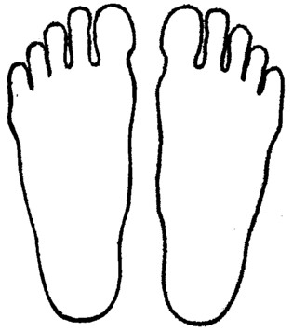
RIGHT LEFT

COMMENTS/ADDITIONAL REQUESTS: ________________________________________________________________________________________________________________________________________________________________________________________________________________________________________________________________________________________
TRACKING NUMBER-PLEASE KEEP A COPY FOR YOUR RECORDS:

Office Use Only

Please do NOT fax this form!
This form must be sent to Orthofeet Inc. with corresponding impression foam box. Please call 1-800-524-2845 Ext. 107 for any questions or comments.
Thank you for Your Business!

